**Description of Itinerary and Segments Tables**

Each Instance of an Itinerary is defined in the data_GroupItineraryDefinition Table.

For a Group, multiple itineraries will exist, some will have many travellers attached, some may have only one traveller attached. Typically when a Group is created, three Itineraries are also created, one for each traveller type (Athlete, Coach and Supporter).

When each Traveller is registered into the system, they are assigned (attached to) the itinerary that is the default for their traveller type.

When created, the Itinerary is blank, not containing any Segments. Each Segment that is created, is defined in the data_GroupSegmentDefinition Table. There are five types of Segments (SegmentServiceType), Flight, Accommodation, Transfer, Car Hire, Tour, Comment and Own Arrangement.

The data_GroupSegmentDefinition has many field to accommodate all of these parameters. Rather than create a general Segment Table, I have specifically created fields for each segment type, which isn’t efficient, but it has simplified some things.

When each Segment is created, for example a Flight segment..

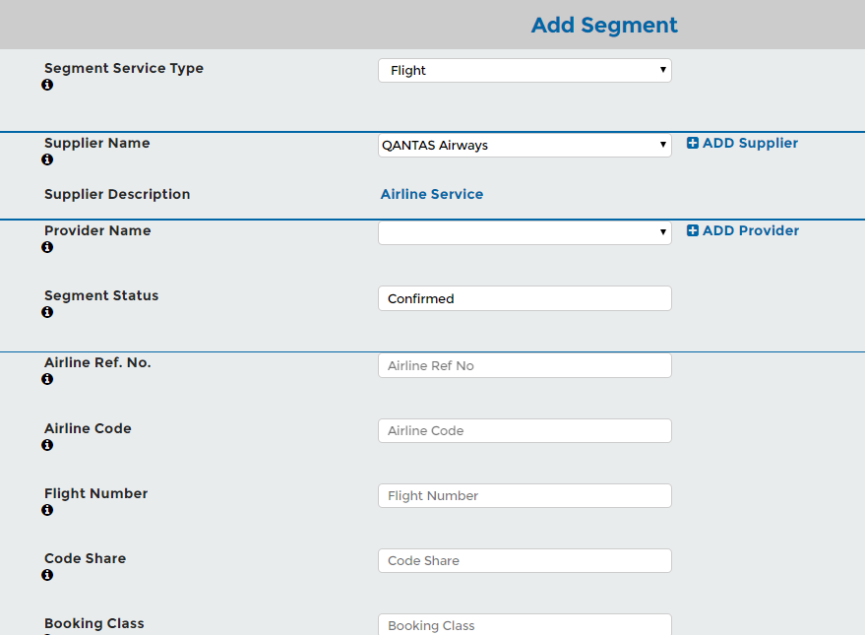

The user can select which Itinerary to add the Segment to…

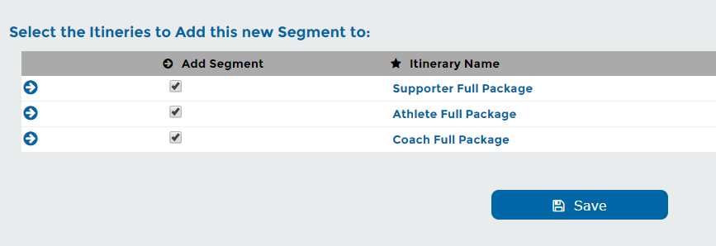

The relationship is then defined in the data_GroupItinerarySegmentList

The advantage here is that changing the parameters of the Segment (e.g. Departure Date) then is reflected across any Itinerary that contains the Segment.

Each Segment will have the option for Notes to be added below the Segment when it is displayed on the Itinerary. These notes are defined in the data_GroupSegmentNotes. Further to this, notes below the segment specific to the traveller can be displayed and are stored in the data_ GroupSegmentNotesTraveller.

Each Traveller is assigned to an Itinerary. A new field has been added to the data_TravellerDetails table, the GrItUID field. This is assigned when the user registers and can be re-assigned at any time.

When a Traveller or group of Travellers deviate from the standard Group Itinerary, a new custom Itinerary for these Traveller(s) is created. A new Itinerary can be created from scratch (empty) and segments added manually, or a new Itinerary can be created and filled with Segments from an existing Itinerary. The Segments that need to be modified for this new Itinerary can be copied, so they do not reflect changes across all other Itineraries.